Dear …

Sincerely,

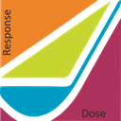

P.O. Box 1681

Richland WA 99352

United States

[LowDoseRad.org](http://www.LowDoseRad.org)